DOS Day of Show Registration
PR
R
Check-In for Pre-Registered Cars

Women’s Restroom
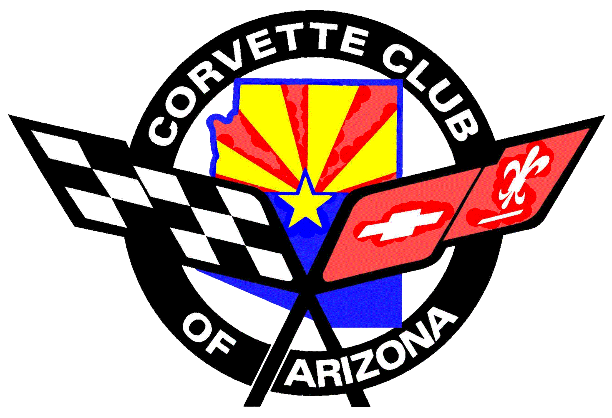
Men’s Restroom
Corvette Club of Arizona Event Office

Packages from Home
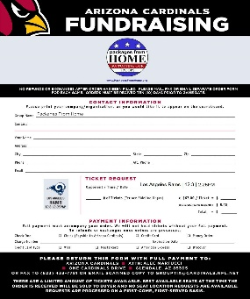
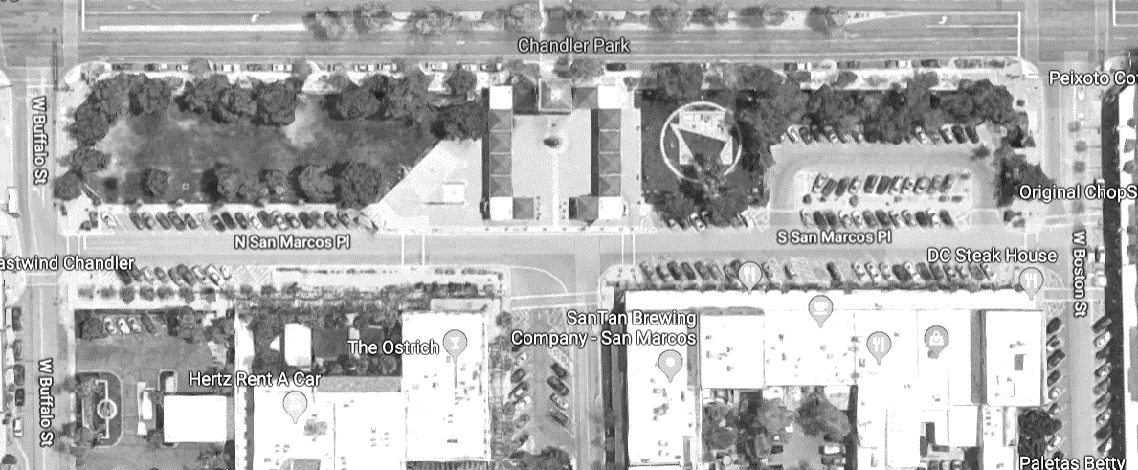
Show
Cars
Enter
PR
R
Day of Show Registration
re
Pre-Registered Cars Check-In
Arizona Ave
Buffalo St.
Boston St.
No
Entry
Vendors

DOS
DOS Park

12


Garbage Cans ‘A’ Frame Signs

No
Entry
9
EC
14
13
11
10
8
7
5
4
3
2
1
6
Vendors
Car Classes

Barricades
Vendor Booths
All Cars will be parked using angled parking, except for the Ramada Area and west side of N. San Marcos Pl.
We are required to keep a road access clearance (20ft) as well as keeping crosswalks and access to fire hydrants open for emergency vehicle access.
Please take the time to visit the 20+ Merchants & Restaurants in the area.
They will appreciate your business!

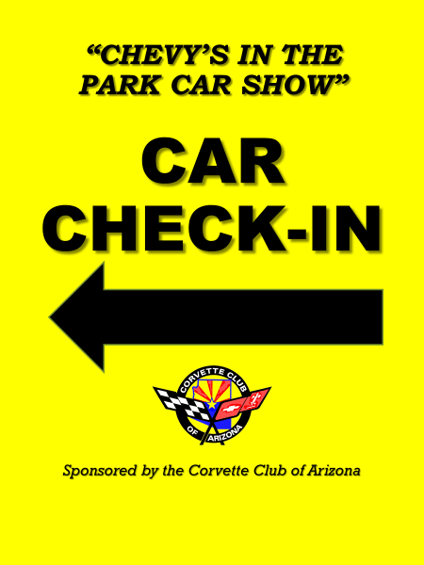

Corvettes | Full Size Chevrolets | Camaros | Novas | Vegas | Chevy Powered Only
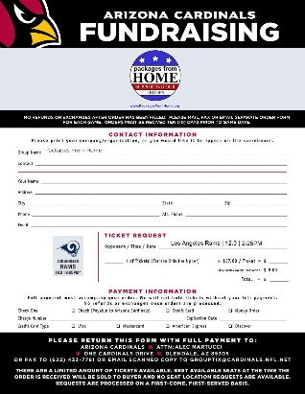  C1: 1953 – 1962 | A1: Older – 1954 | B1: 1967 – 1969 | E1: All Years | H1: All Years | L1: All Years
C2: 1964 – 1967 | A2: 1955 – 1964 | B2: 1970 – 1981 | Chevy Trucks | Pro-Street
C3: 1986 – 1982 | A3: 1965 – 1973 | B3: 1982 – 1992 | G1: Older – 1967 | I1: All Years | Exhibition Class
C4: 1984 – 1996 | A4: 1974 – Present | B4: 1993 – 2002 | G2: 1968 – Present | Full Race Car/Truck | EC: All Years*
C5: 1997 – 2004 | Chevelle – El Camino | B5: 2010 – Present | G3: Avalanche | J1: All Years | *not judged
C6: 2005 – 2013 | D1: Older – 1967 | Corvair | G4: SSR | Street Rod
C7: 2014 - Current | D2: 1968 – Present | F1: All Years |  | K1: All Years | Rev 0 - 04/19/19
For Corvette Club of Arizona Use Only
Location | Parking Area | Max Cars | Car Classes
S. San Marcos Pl. | 1&2 | 25 | Note: Start PA1 - PFN
S. San Marcos Pl. | 3 | 12 | Note: PFN,
S. San Marcos Pl. | 4 | 8 | Note: overflow for C7 into PA3
Ramada | 5 | 25 | Note:
Ramada | 6 | 8 | Note: PFS
Ramada | 7 | 12 | Note: PFN
N. San Marcos Pl. | 8&9 | 18 | Note: Start PA8 - PFS
N. San Marcos Pl. | 10&11 | 8 | Note: PA10 - PFS, leave space for crosswalk
N. San Marcos Pl. | 12 | 10
Corral | 13 | 12 | Note: PFN
Corral | 14 | 16 | Note: PFN
Exhibition | EC | 1 | EC(1) Note: in front of American Flag
 |  | 154
PFN - Park from North
PFS - Park from South
PA# - Parking Area Number, i.e. PA1, PA2, etc

Avg | 2019 | Corvettes | Avg | 2019 | Full Size Chevrolets | Avg | 2019 | Camaros | Avg | 2019 | Novas
 |  | C1: 1953 – 1962 |  |  | A1: Older – 1954 |  |  | B1: 1967 – 1969 |  |  | E1: All Years
 |  | C2: 1964 – 1967 |  |  | A2: 1955 – 1964 |  |  | B2: 1970 – 1981 |  |  | Chevy Trucks
 |  | C3: 1986 – 1982 |  |  | A3: 1965 – 1973 |  |  | B3: 1982 – 1992 |  |  | G1: Older – 1967
 |  | C4: 1984 – 1996 |  |  | A4: 1974 – Present |  |  | B4: 1993 – 2002 |  |  | G2: 1968 – Present
 |  | C5: 1997 – 2004 |  |  | Chevelle – El Camino |  |  | B5: 2010 – Present |  |  | G3: Avalanche
 |  | C6: 2005 – 2013 |  |  | D1: 1964 – 1967 |  |  | Corvair |  |  | G4: SSR
 |  | C7: 2014 - Current |  |  | D2: 1968 – Present |  |  | F1: All Years
Avg | 2019 | Vegas | Avg | 2019 | Full Race Car/Truck |  | 2019 | Chevy Powered Only
 |  | H1: All Years |  |  | J1: All Years |  |  | L1: All Years
 |  | Pro-Street |  |  | Street Rod |  |  | Exhibition Class
 |  | I1: All Years |  |  | K1: All Years |  |  | EC: All Years*
 |  |  |  |  |  |  |  | *not judged |  |  | Rev 0 - 04/19/19

